Inverted Heel Rubber Hinge CAD

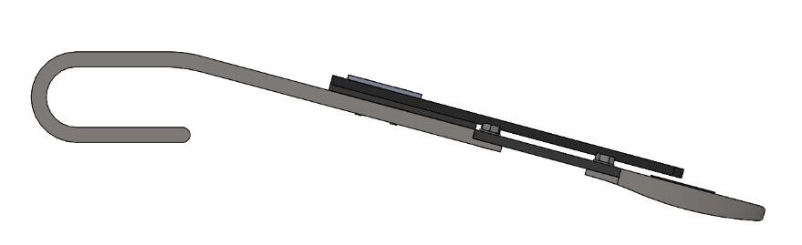
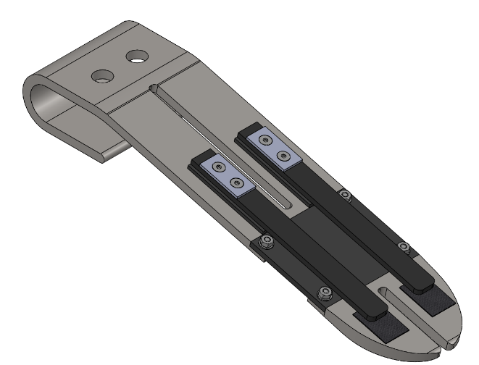
(a)
(b)

